Xestia Address Book
Version 0.1.0 Documentation
Table of Contents
Introduction 3
System Requirements 4
Installation from pre-built installer 5
Windows 5
OS X 5
OpenSuSE 5
Installation from source 6
Windows 6
OS X 6
OpenSuSE 7
Application Operation 8
Main window 9
Creating an account 10
Contacts 11
Adding a contact 12
Editing a contact 13
Deleting a contact 14
Searching 15
Importing and Exporting 16
Importing 17
Exporting 18
Preferences 19
General Tab 20
Accounts Tab 21
Creating an account 22
Editing an account 23
Deleting an account 24

Introduction

Xestia Address Book is an address book application which allows you to store the contact details of people and organisations.
The contact editor is built upon the vCard 4.0 specification allowing you to store personal, business, pictures, logos and even sounds.
This application has native CardDAV support so you can synchronise it to a server and they will appear in all of your address book clients on the systems you use.

System Requirements
OpenSuSE 13.2
1 Ghz processor
100 MB free space
2GB RAM
If you are installing from source (not from a pre-built installer) be aware of the following library requirements:
wxWidgets – version 3.0
SFML – version 2.1 (system and audio libraries required, remaining libraries optional)
libxml2 – version 2.9.2
iconv – version 1.14
file – version 5.03
curl – version 7.44

Installation from pre-built installer

OpenSuSE
Download the pre-built package and then double click on it.
The package installer will then install Xestia Address Book along with the required dependences for the application.
After Xestia Address Book is installed, the package can then be archived or deleted.

Installation from source
Important: If you are using a pre-built installer instead of building from source you can skip this section.

OpenSuSE
Before starting check that the required dependencies are installed along with their development files.
You will need to download and install SFML 2.1 separately.
After extracting the source code, open a console and change the directory to the directory with the source code.
Type in the command and run
./configure
This will then check that the libraries are installed and their development files are available.
When the configuration script has finished, type in and run
make
This will compile Xestia Address Book.
When compilation has finished, type in
make install
This will install Xestia Address Book to the standard /usr/local directory.
To start Xestia Address Book from the console or as a shortcut use the following command:
xestiaab

Application Operation
This section of documentation describes how to use Xestia Address Book.
It is split into five parts:
- Main window
- Creating an account
- Contact editor
- Searching
- Importing and Exporting
- Preferences

Main window
The main window is where the displaying of the list contacts and contact information takes place.
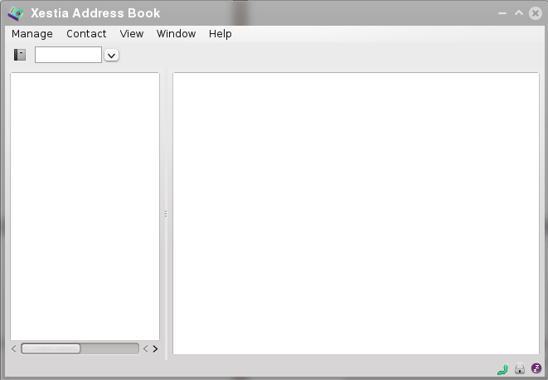
To view the contacts associated with an account, click on the drop down arrow and select an account.
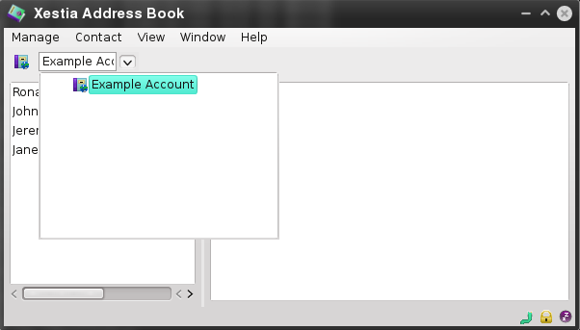
This will then display the list of contacts for the account.
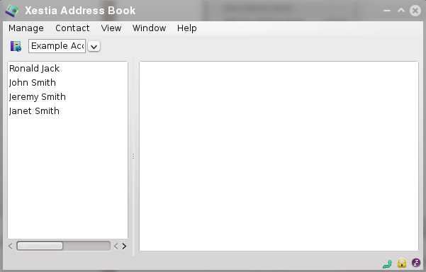
Select a contact from the contact list and it will be display in the viewer.

Creating an account
To create an account for use with Xestia Address Book, click on the Manage menu item from the main window and click on New Address Book.
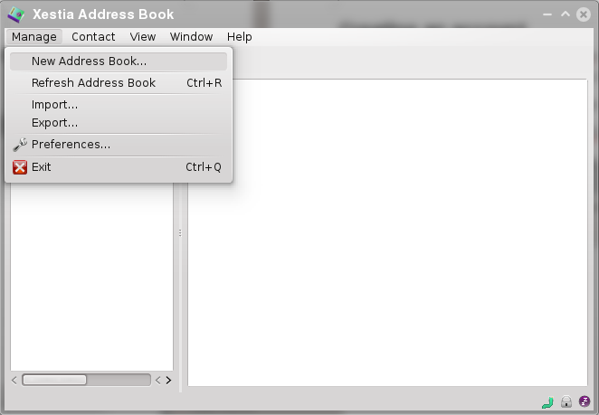
Select your account type of either CardDAV or Local.
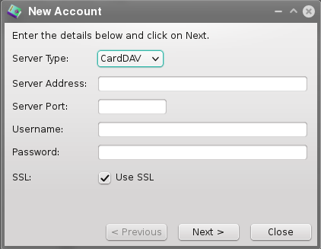
Local accounts will not require server information to be entered.
Click on Next and the application will then try to connect to the server and get the required information from the server.
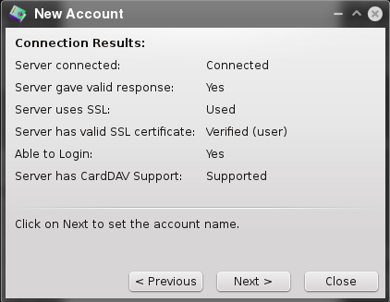
After the reviewing the information either click on Next to continue to Previous to review the account information.
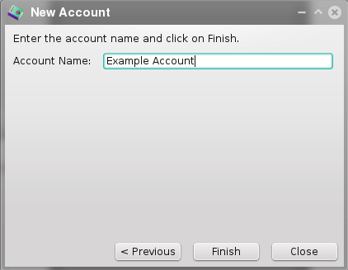
Confirm the account name and click on finish.
The account is then added to the list.

Contacts
Manage your contacts by adding, editing or deleting them from your address books.

Adding a contact
To add a contact, select an account from the main window, click on the Contact menu item and click on New Contact.
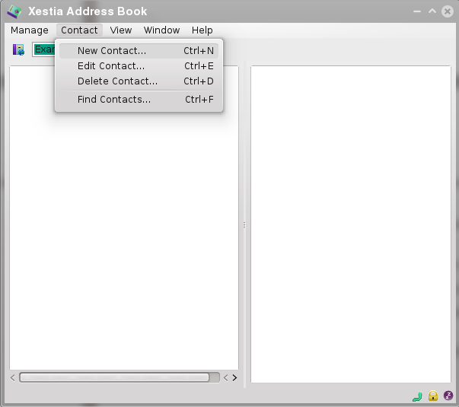
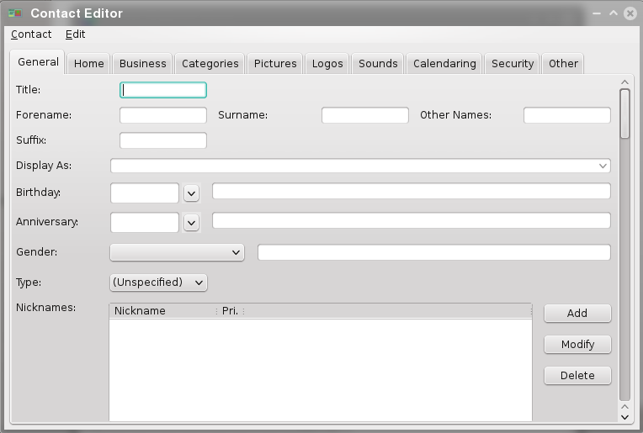
The contact editor window then appears.
There are 11 tabs within the contact editor window:
- General – General information about the contact such as name, birthday, anniversary, gender, type and contact details.
- Home – Information about the contact's home details.
- Business – Information about the contact's business details.
- Categories – Categories that the contact belongs to.
- Members – Lists the members of a group. If the contact type is a group, then the members tab will appear.
- Pictures – Pictures that the contact has.
- Logos – Logos that the contact has.
- Sounds – Sounds and Audio that the contact has.
- Calendaring – Calendar details for the contact.
- Security – Security keys such as PGP keys.
- Other – Other information.
To add information to the contact, select the information you want to add and then click on Add on the right hand side.
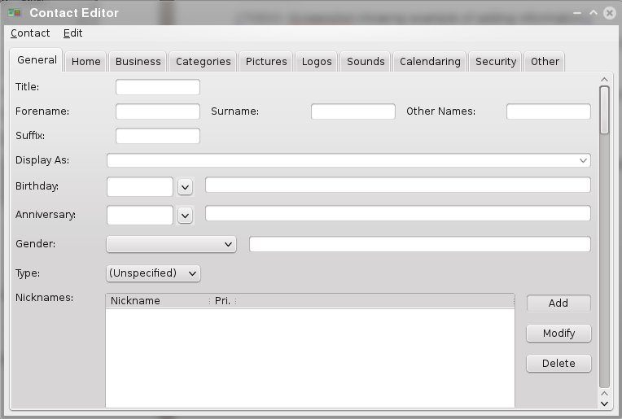
From the window, enter the information and click on Add. This will add the information to the contact.
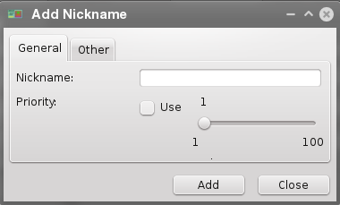
To edit information select the information you want to edit from the list and click on Edit.
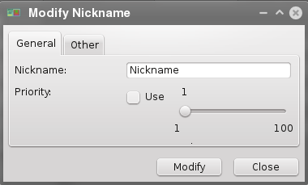
To delete information select the information you want to delete from the list and click on Delete.
To save the contact, click on Contact and select either Save or Save and Close Contact.

Editing a contact
To edit a contact, select a contact in the main window and then click on the Contact menu item and select 'Edit Contact'.
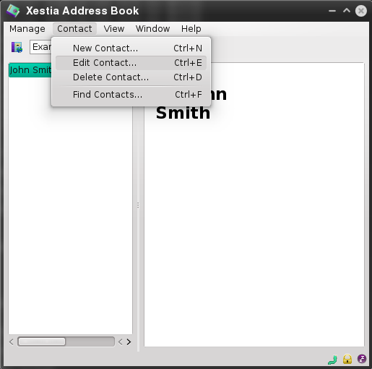
The interface for editing a contact is exactly the same as adding a contact.
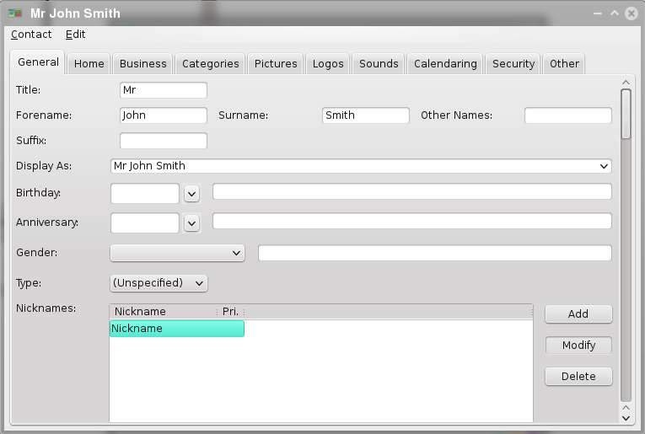
When you have finished editing, click on Contact and select either Save or Save and Close Contact.

Deleting a contact
To delete a contact, select a contact from the list in the main window and then click on Contact in the menu and select Delete Contact.
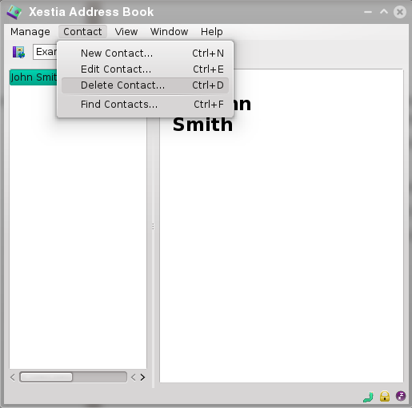
A dialog will then appear to confirm if you want to delete this contact.
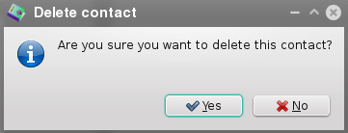
Clicking on Yes will delete the contact from the address book and CardDAV server.

Searching
If you have many contacts within an address book account, you can do a search to find certain contacts.
To open a search window, click on the Contact menu in the main window and click on Find Contacts.
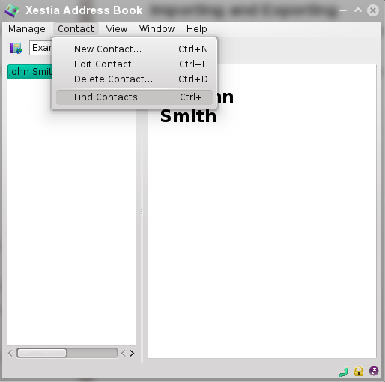
A Search Contacts window will then appear.
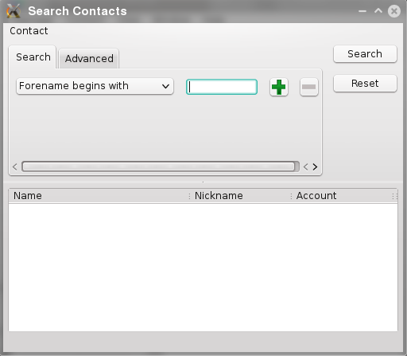
Select how you want to search the contact lists from the drop down menu.
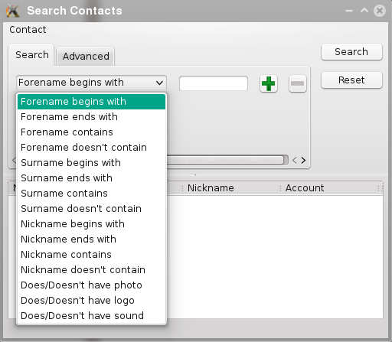
Enter the parameters required and click on Search. To stop searching at any time, click on Stop.
After searching, the contacts that match the parameters given will appear in the results list.
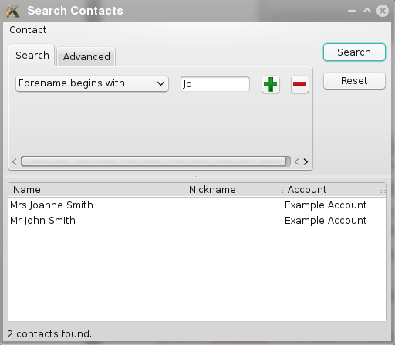
Up to 15 search parameters can be set using the plus and minus buttons. To adjust the list of accounts being searched, click on the Advanced tab and click on Select Accounts.
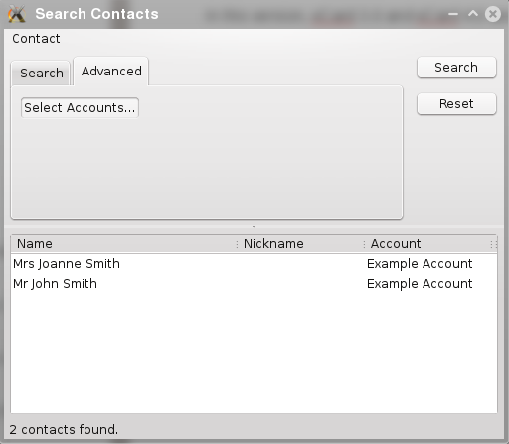
Select or deselect the accounts you want by checking or unchecking the boxes next to the account name.
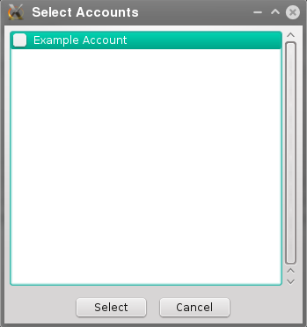
To open a contact, click on the contact and from the Contact menu click on Open Contact. This will bring up the contact in a new window.
To edit a contact, click on the contact and from the Contact menu click on Edit Contact. This will load the contact into the contact editor.
To reveal a contact in the main window, click on the contact and from the Contact menu click on Reveal Contact. This will display the contact in the main window.

Importing and Exporting
Importing and Exporting allows contacts to be used in Xestia Address Book or the contacts be used in other applications.
In this version, vCard 3.0 and vCard 4.0 are supported for importing and exporting.

Importing
From the main window, click on the Manage menu item and click on Import.
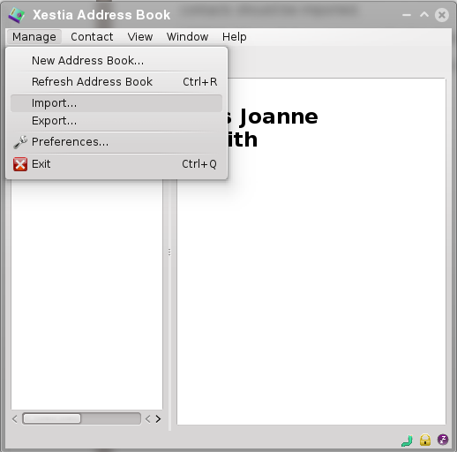
Select the file containing the contacts and click on Open.
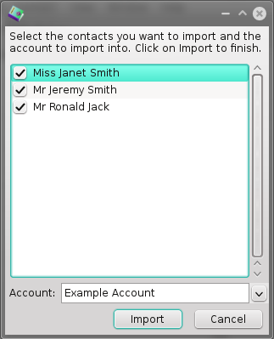
If the contact file contains multiple contacts then a dialog will appear confirming which contacts should be imported.
After selecting or deselecting contacts click on Import.

Exporting
From the main window, select the account you want to export contacts from and then using your Control or Command key select the contacts you would like to export.
When you have finished selecting the contacts, click on the Manage menu item and select Export.
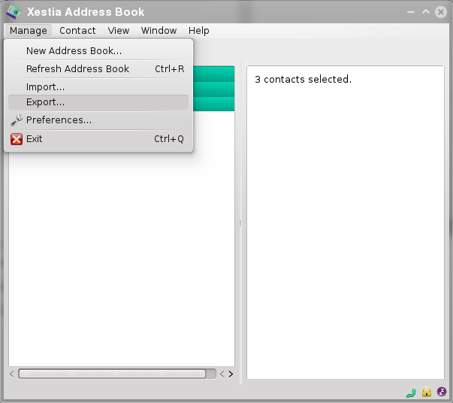
Select the type of file format you want, enter the filename and then click on Save.
The selected contacts will then be exported.

Preferences
Preferences for Xestia Address Book can easily be changed through the Preferences window.
To open the Preferences window, from the main window select the Manage menu and click on Preferences.
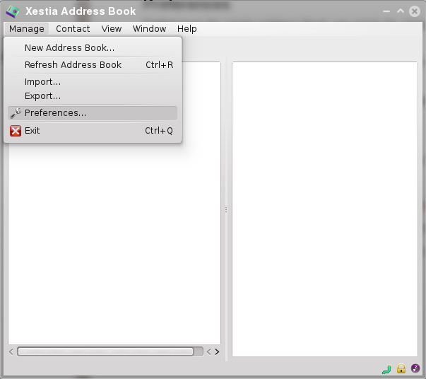
The Preferences window will then appear.
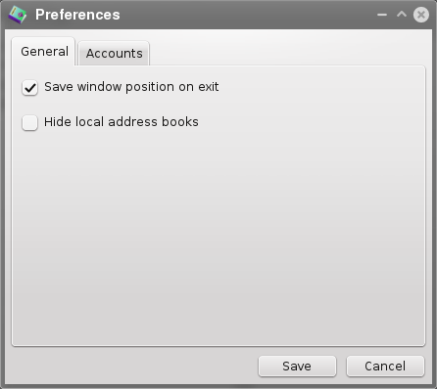
The Preferences window contains two tabs:
- General – Configure general settings within Xestia Address Book
- Accounts – Configure accounts being used within Xestia Address Book
When you have finished editing the preferences, click on the Save button to save the changes made.

General Tab
The general tab has two settings:
- Save window position on exit – This saves the main window position upon exiting.
  - Checked – Saves the main window position on exit and restores the main window position when Xestia Address Book is open again.
  - Unchecked – Main window always open in the centre of the screen when Xestia Address Book is opened.
- Hide local address books – Hides address books which are local.
  - Checked – Hides address books from the list of accounts.
  - Unchecked – Does not hide address books from the list of accounts.

Accounts Tab
The accounts tab allows you to manage the accounts that are being used in Xestia Address Book.
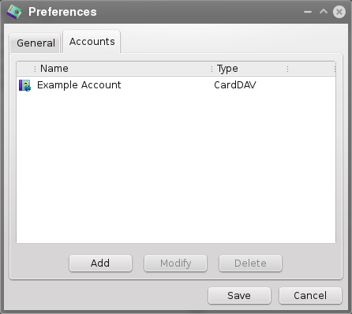

Creating an account
To create an account, click on the New button. This process is exactly the same as Creating An Account.

Editing an account
To edit an account, select and account and click on the Edit button. The window for editing an account will then appear.
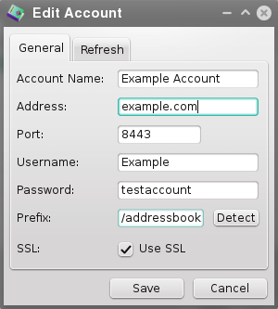
Edit the settings for the account in that screen and click on Save. This will update the settings for the account.

Deleting an account
To delete an account, select an account from the list and click on the Delete button.
A message will then appear asking to confirm if the account should be deleted.
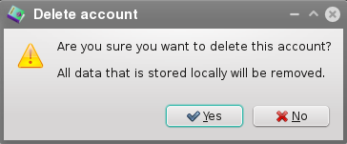
Click on the Yes button to delete the account. The data that was stored locally will also be removed as well.

As described in RFC6350. Does not support the XML property but will preserve it.
As described in RFC6352
This is for the installation of Xestia Address Book only. Contacts may take more space than given in the system requirements.
Control or Command key depends on which operating system you are running Xestia Address book on.

